HikproConnect Troubleshoot

1. HikProConnect TestClient

Path
The HikProConnect TestClient is located at: C:\nxg\testclient\hikProClient
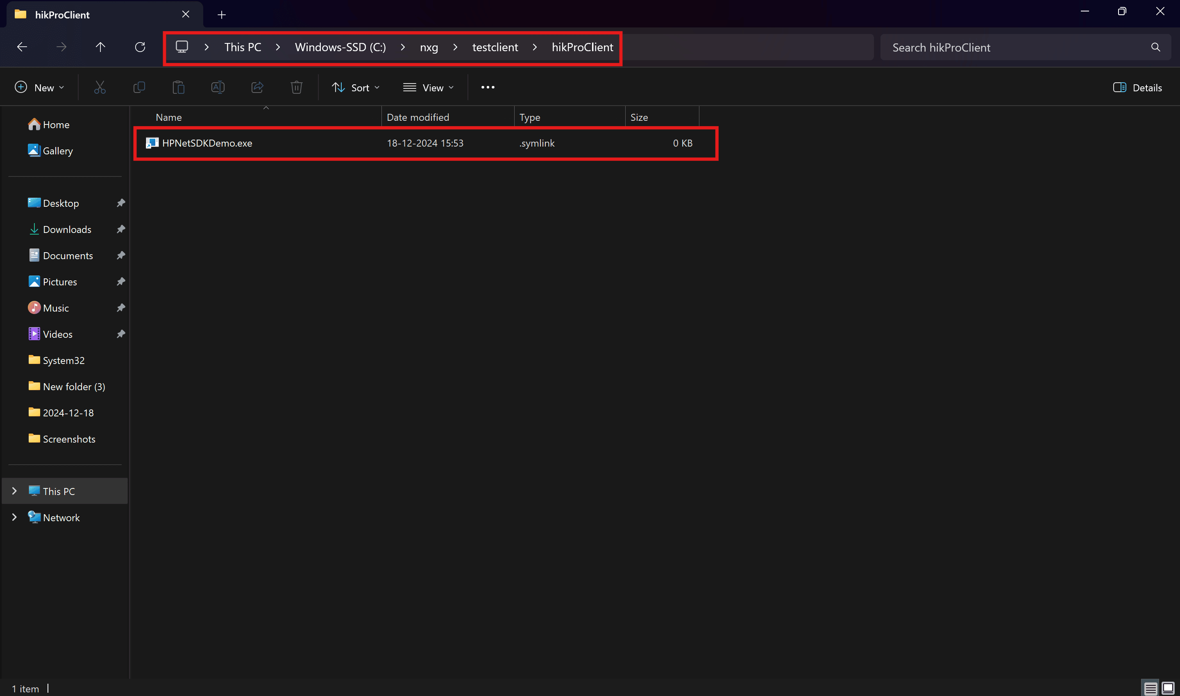

Steps to Verify
- Open the HikProConnect TestClient.
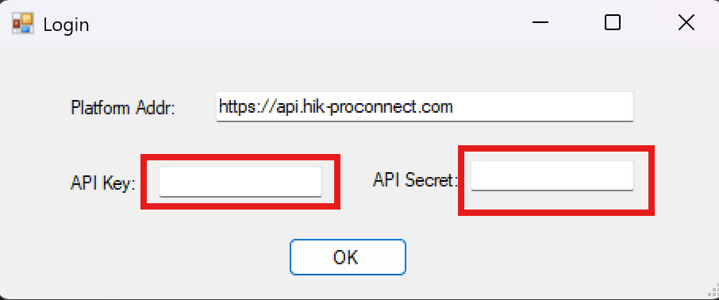
- When prompted, enter the API Key and API Secret credentials. These credentials can be retrieved from the Application.
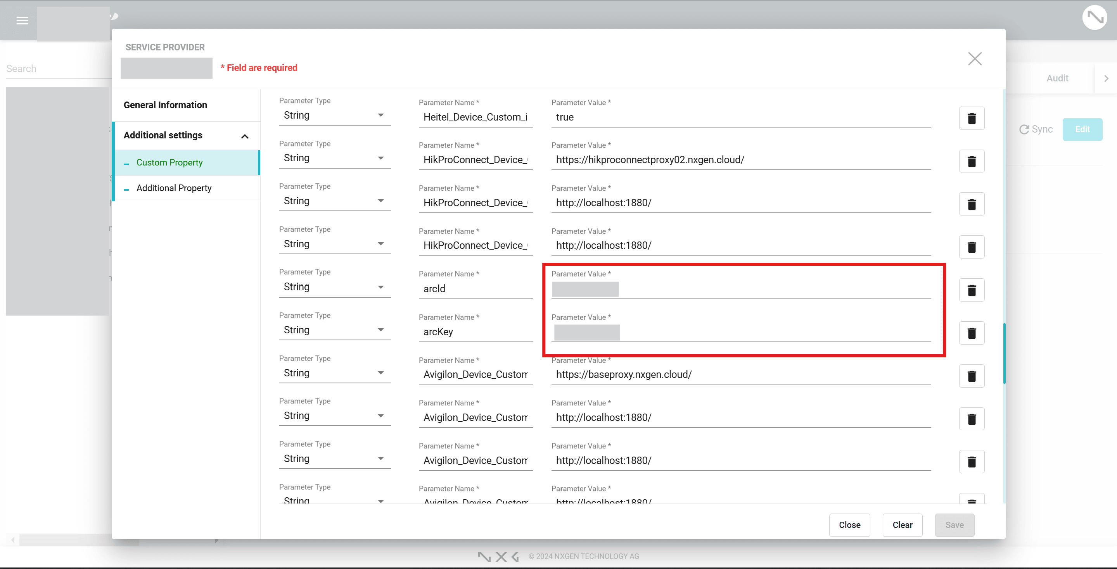
- Once the client opens, provide the following details:
  - Device Serial Number
  - Encryption Key These details are also available from the Application Device Credentials.
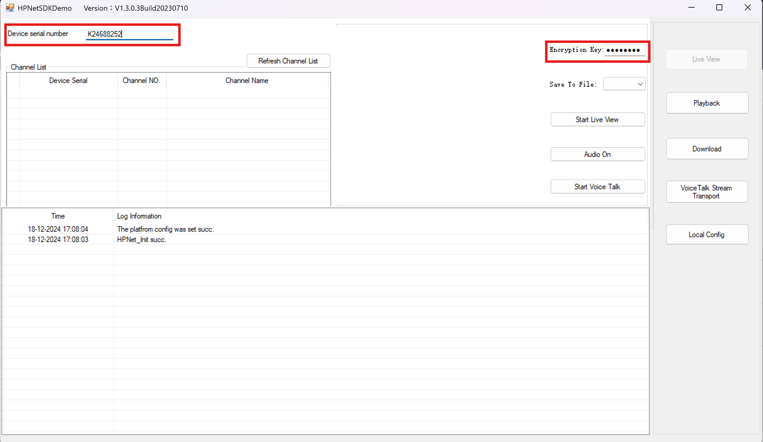
- After entering the required information:
  - Click "Refresh Channel List": A list of sensors will be displayed.

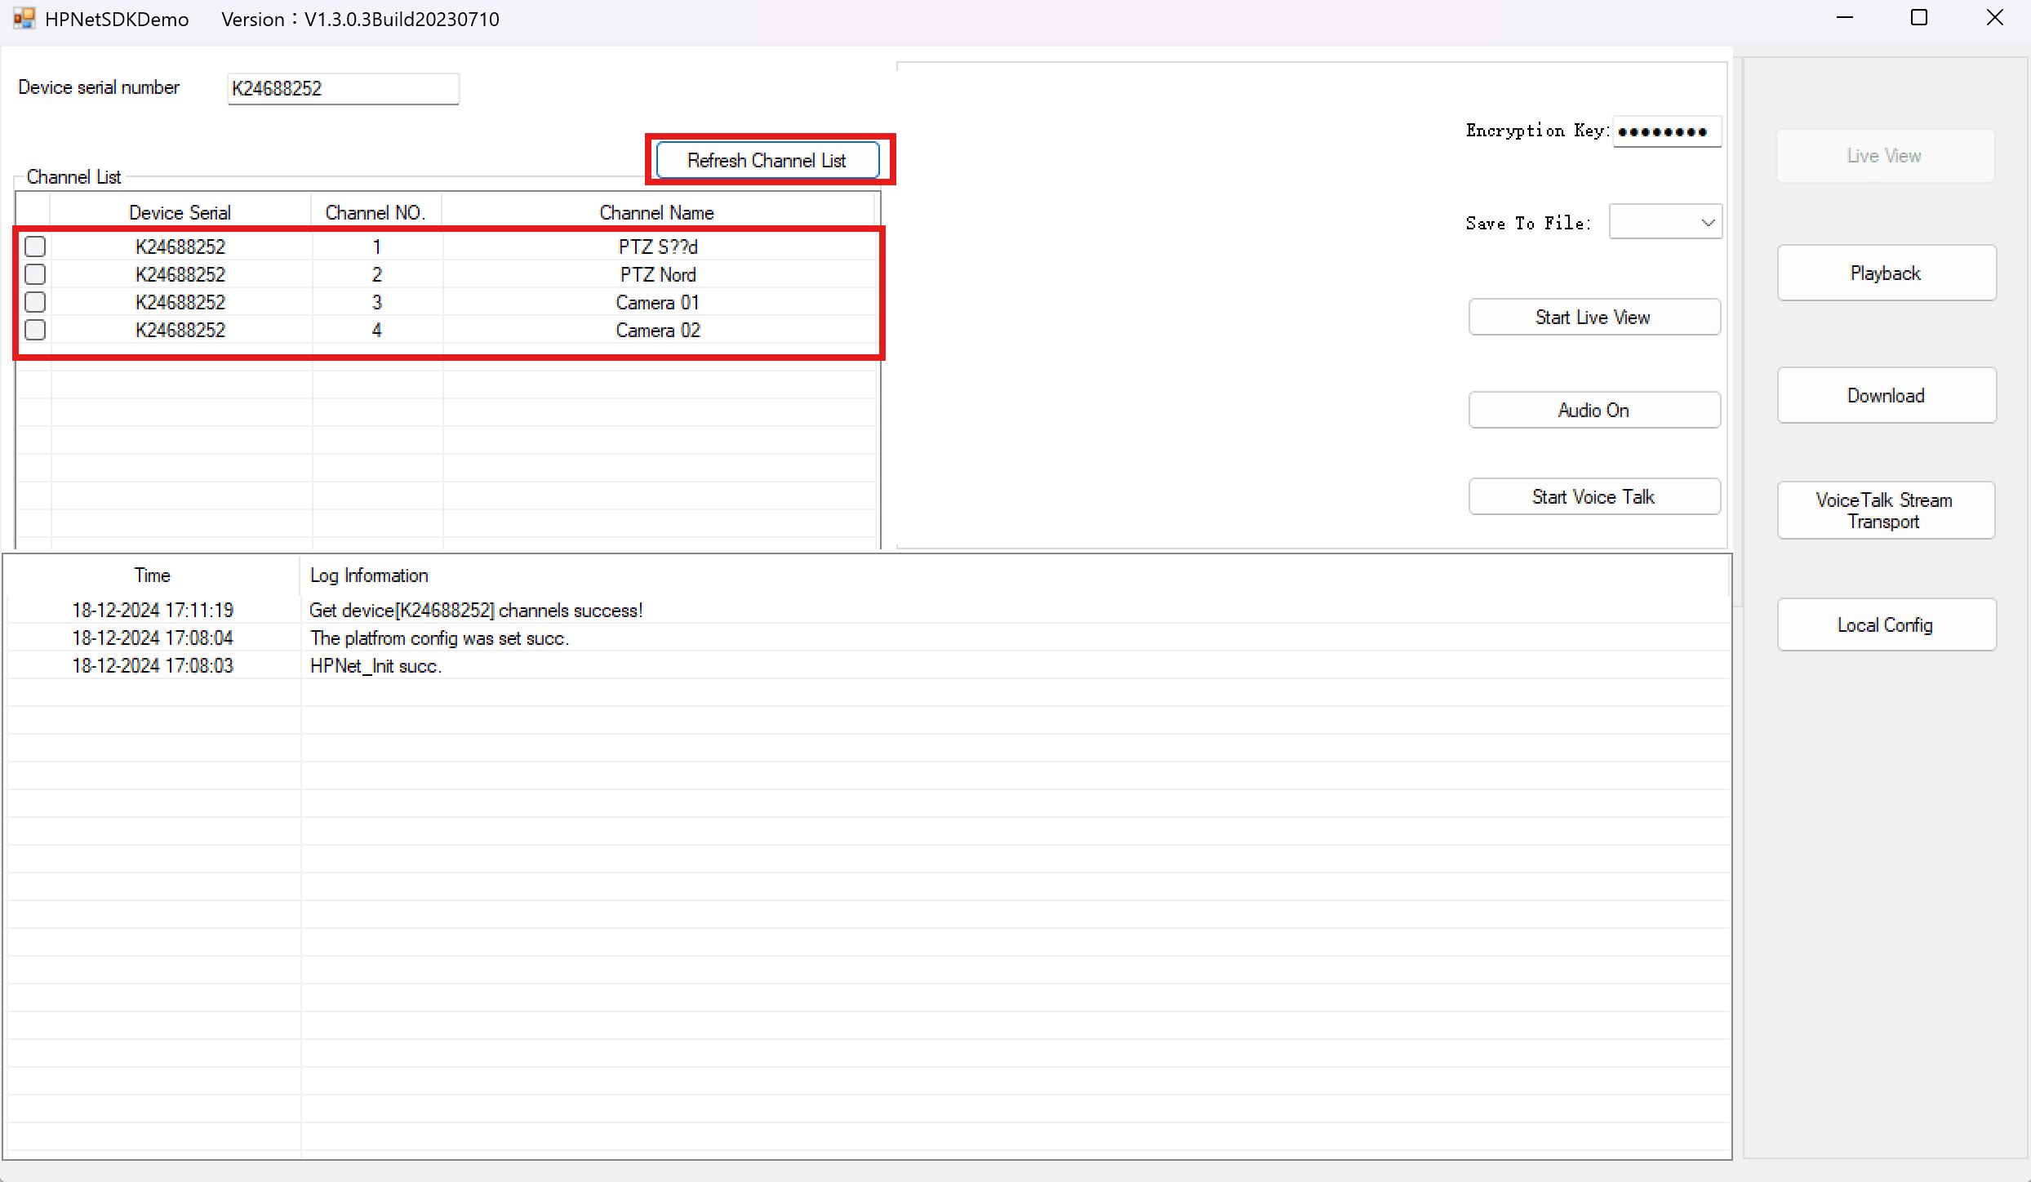
  - Select one or more sensors and click Start Live View to begin streaming the cameras.
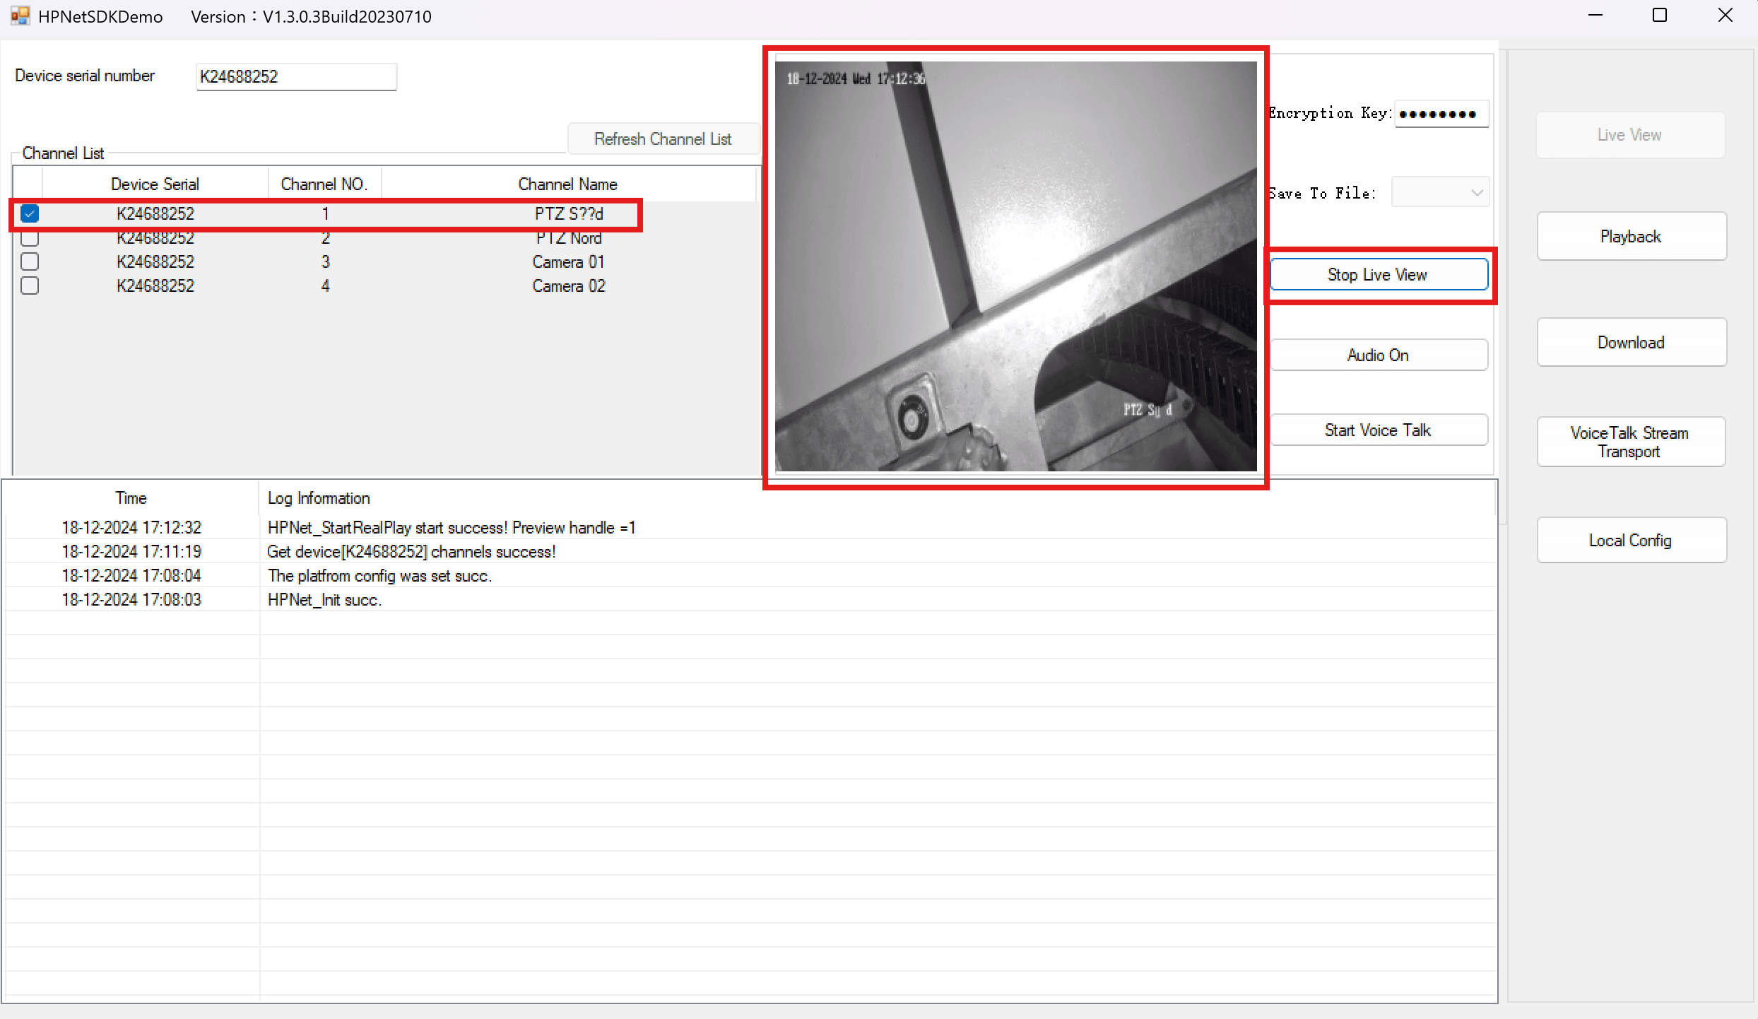

  - To check audio, click Start Voice Talk to activate audio streaming, and Click again to stop the audio stream.
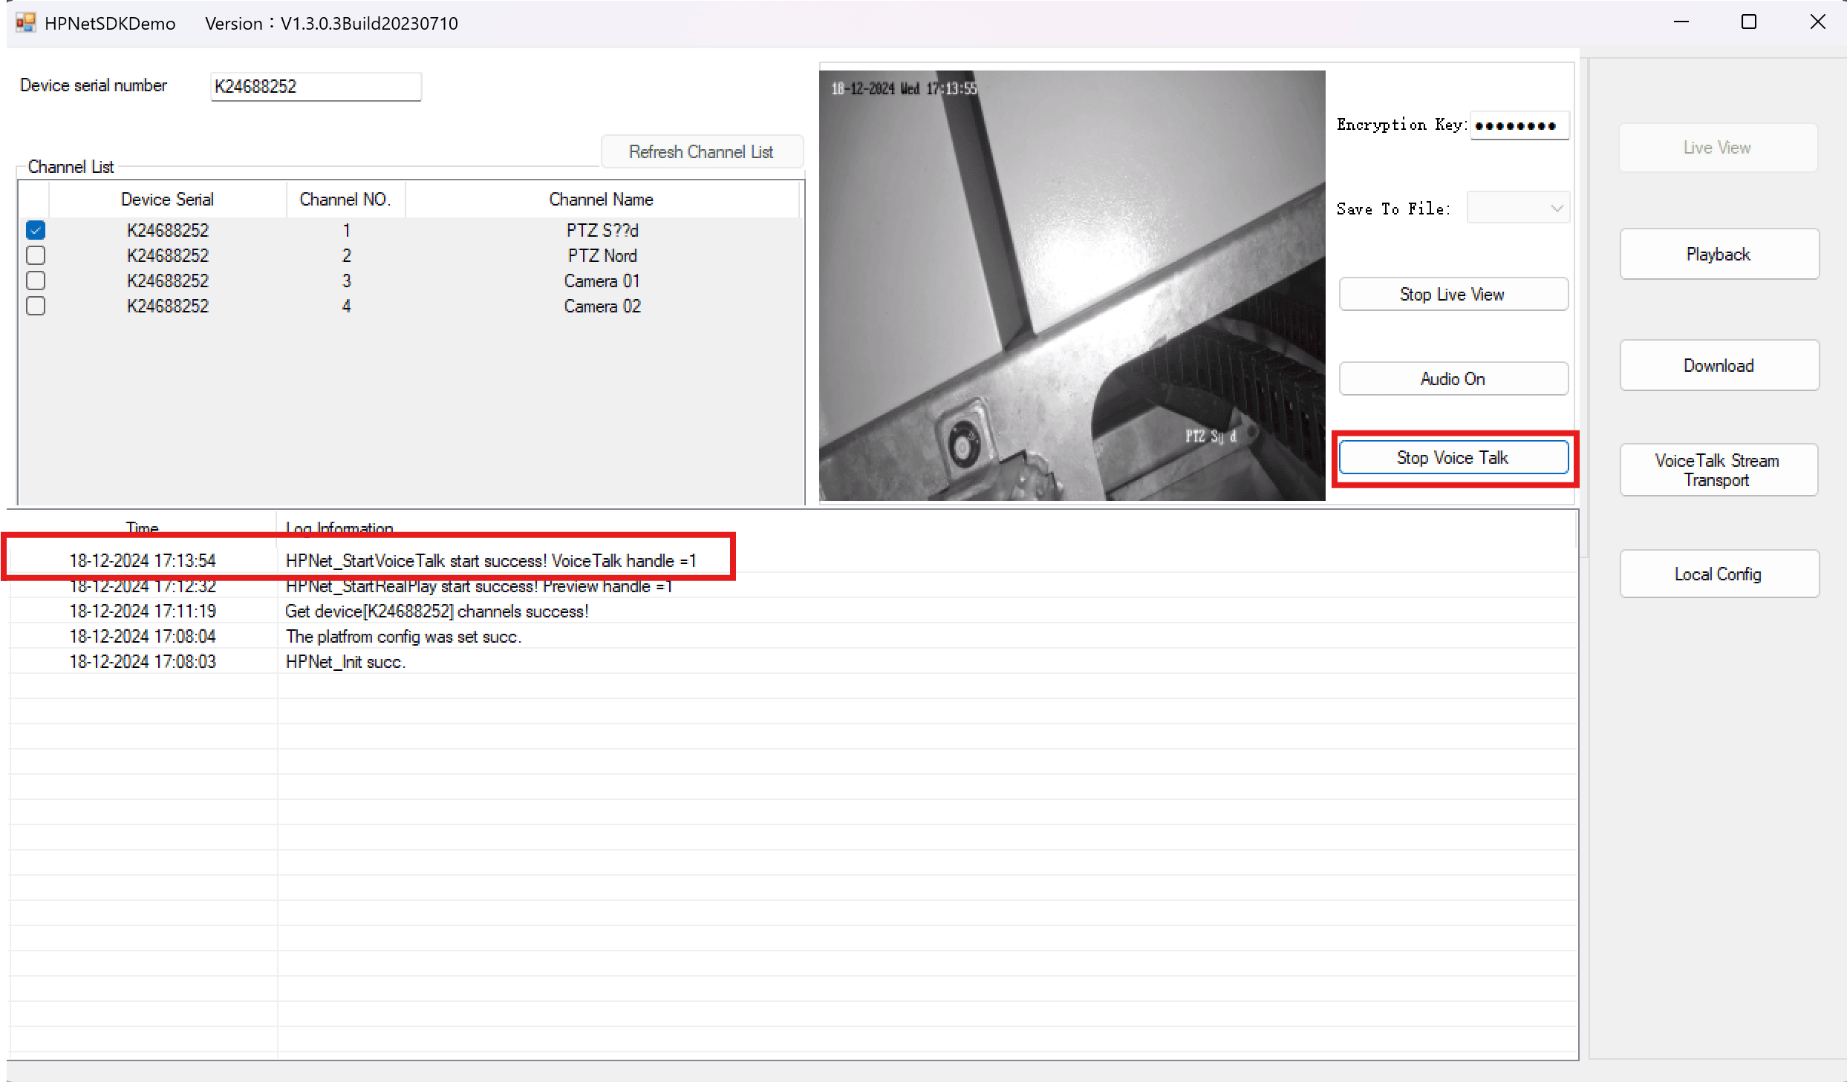

Playback Verification
- Click the Playback button (located at the right-middle section).
- Provide the following information:
  - Device Serial Number
  - Channel Number
  - Encryption Key
  - Start Time and End Time for the playback.

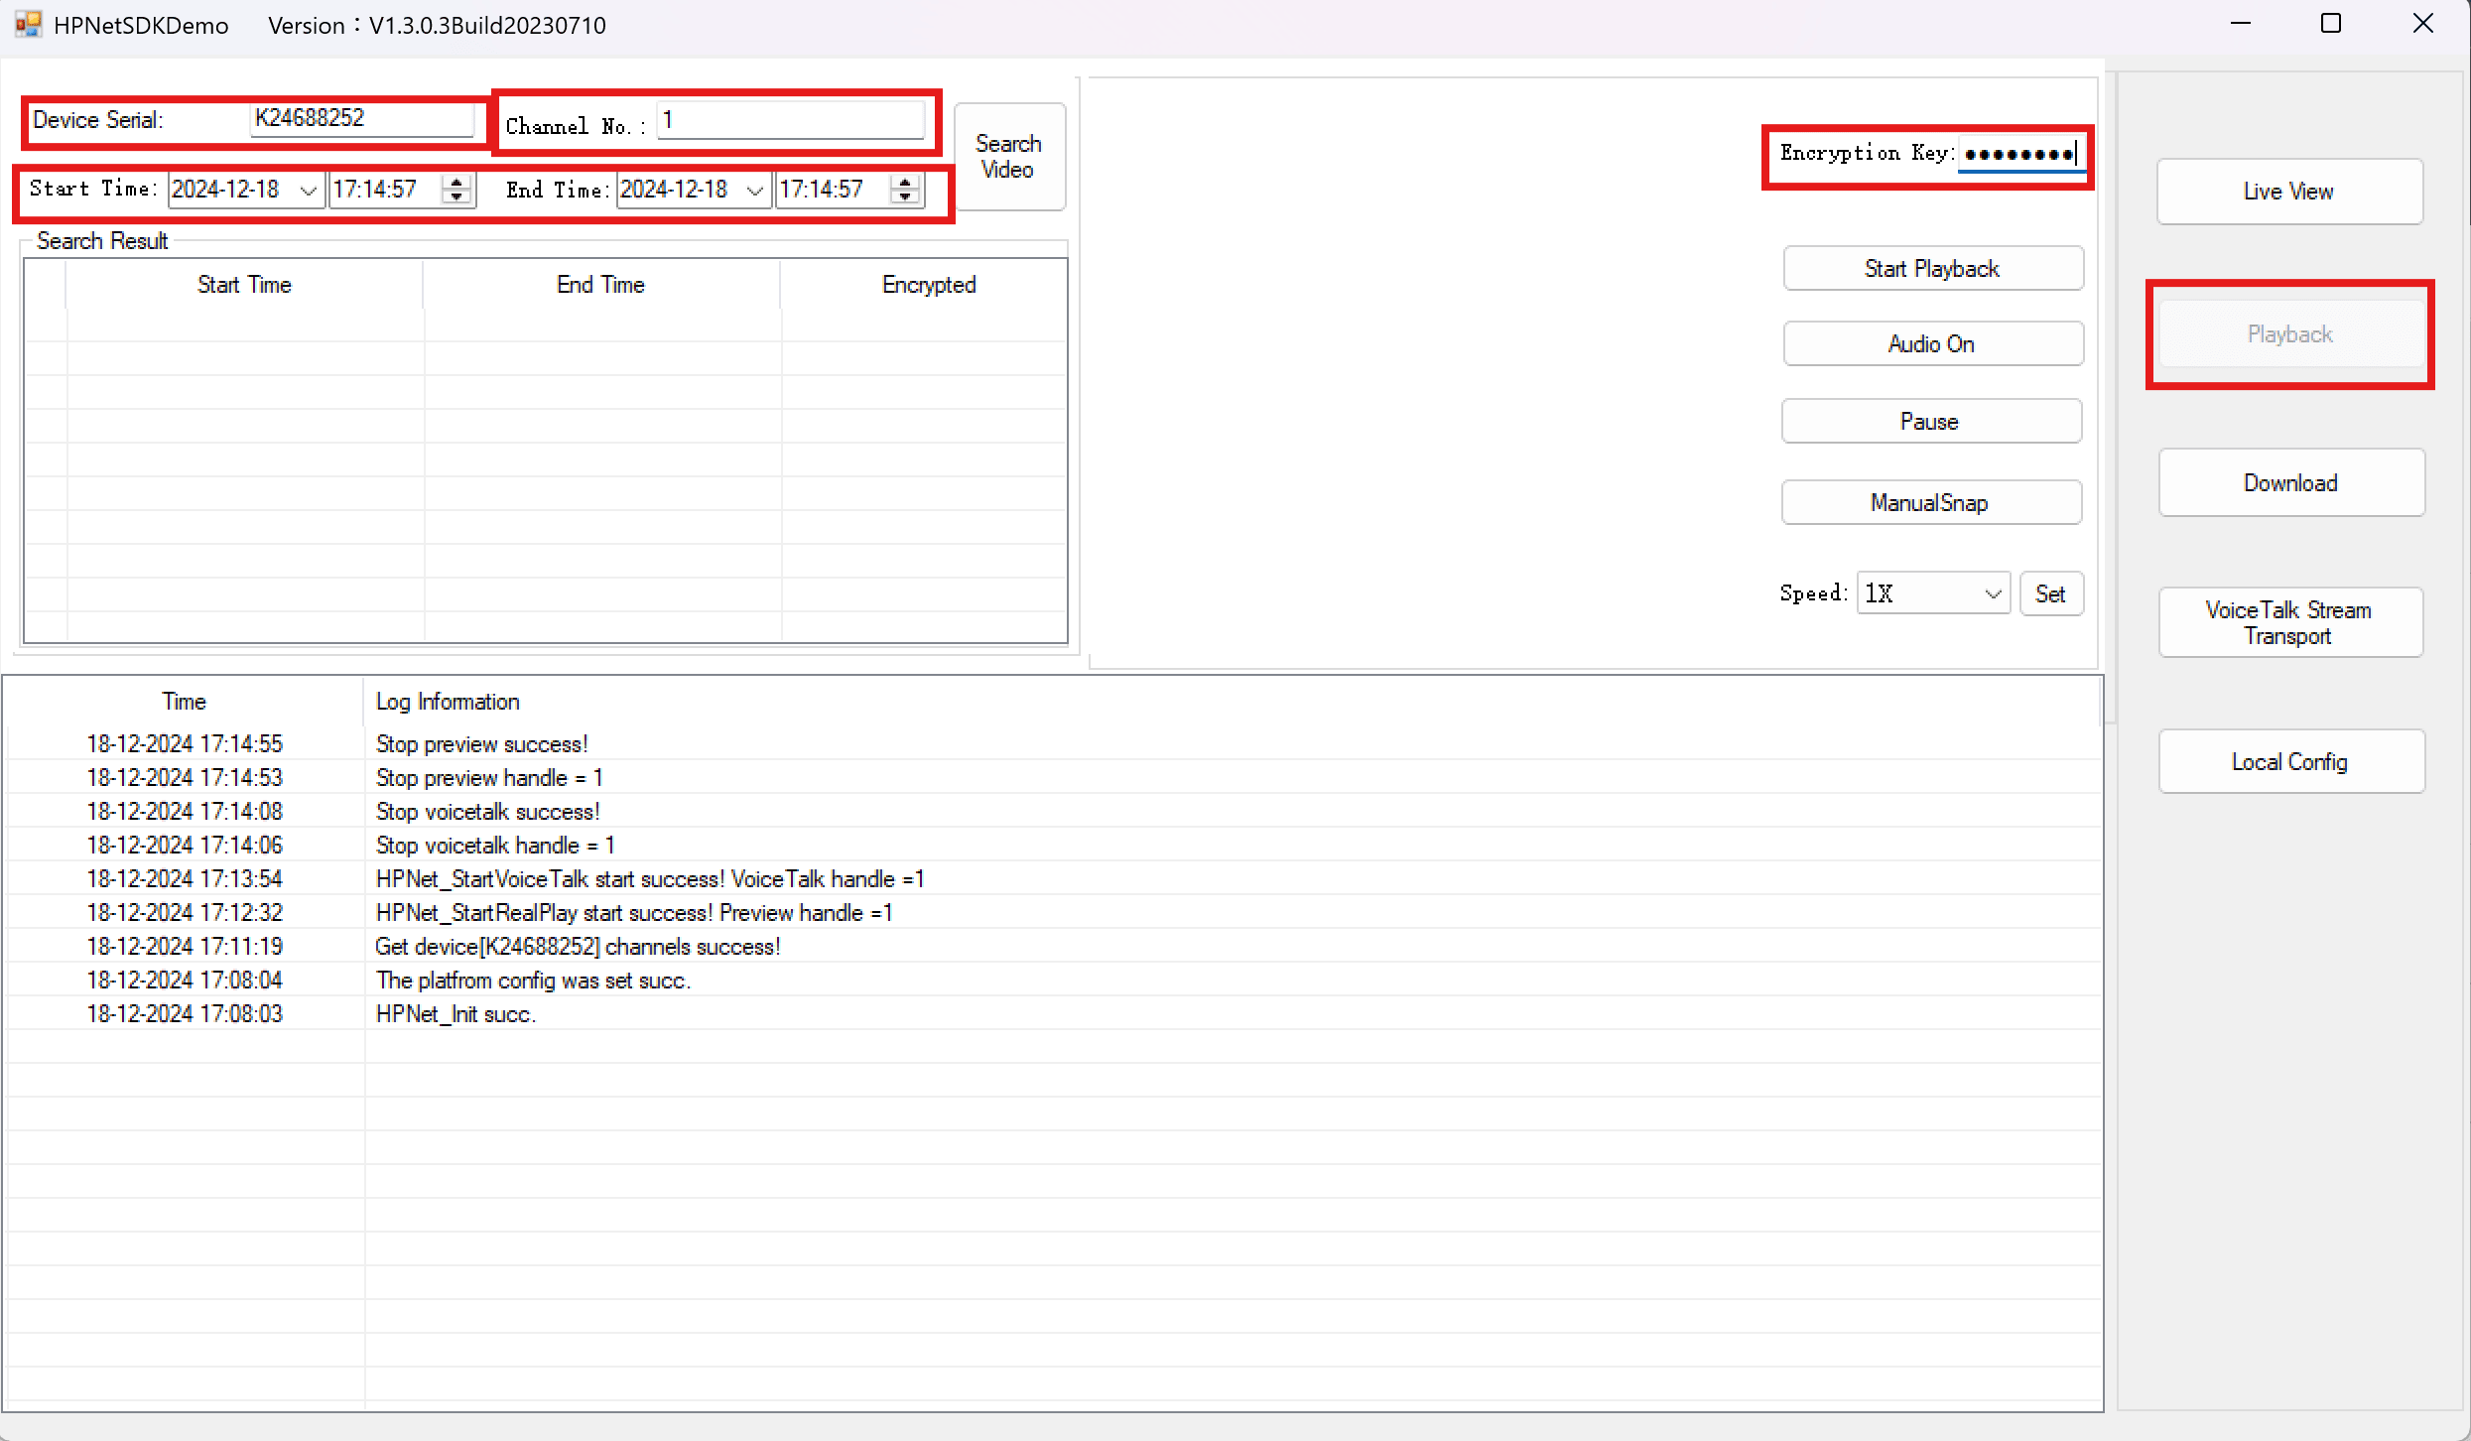
- Click Start Playback to initiate playback for the specified time range.
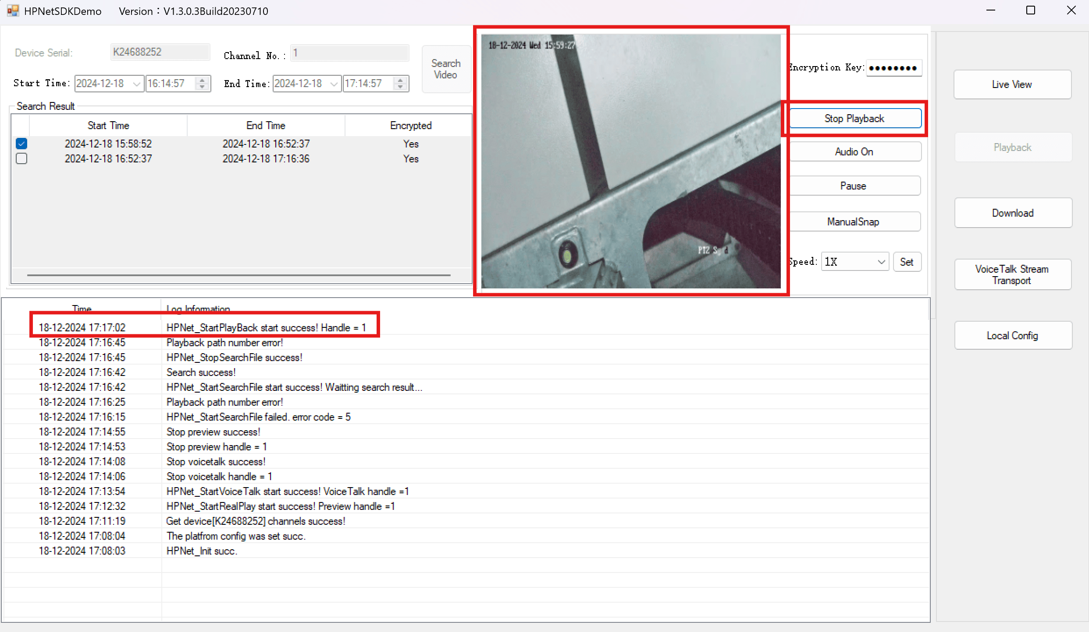
- Verify that streaming occurs correctly for the selected playback time.

Log Verification
Logs are generated within the client app under the log information section. Ensure to check logs for:
- Live View Started
- Audio On and Audio Off
- Playback Success

2. Application Check

Steps to Verify
- Drag and drop the sensors into the Salvo Page Quadrant.
  - Confirm if the video stream plays correctly.
- While playing, click the Audio Button and ensure it is activation.
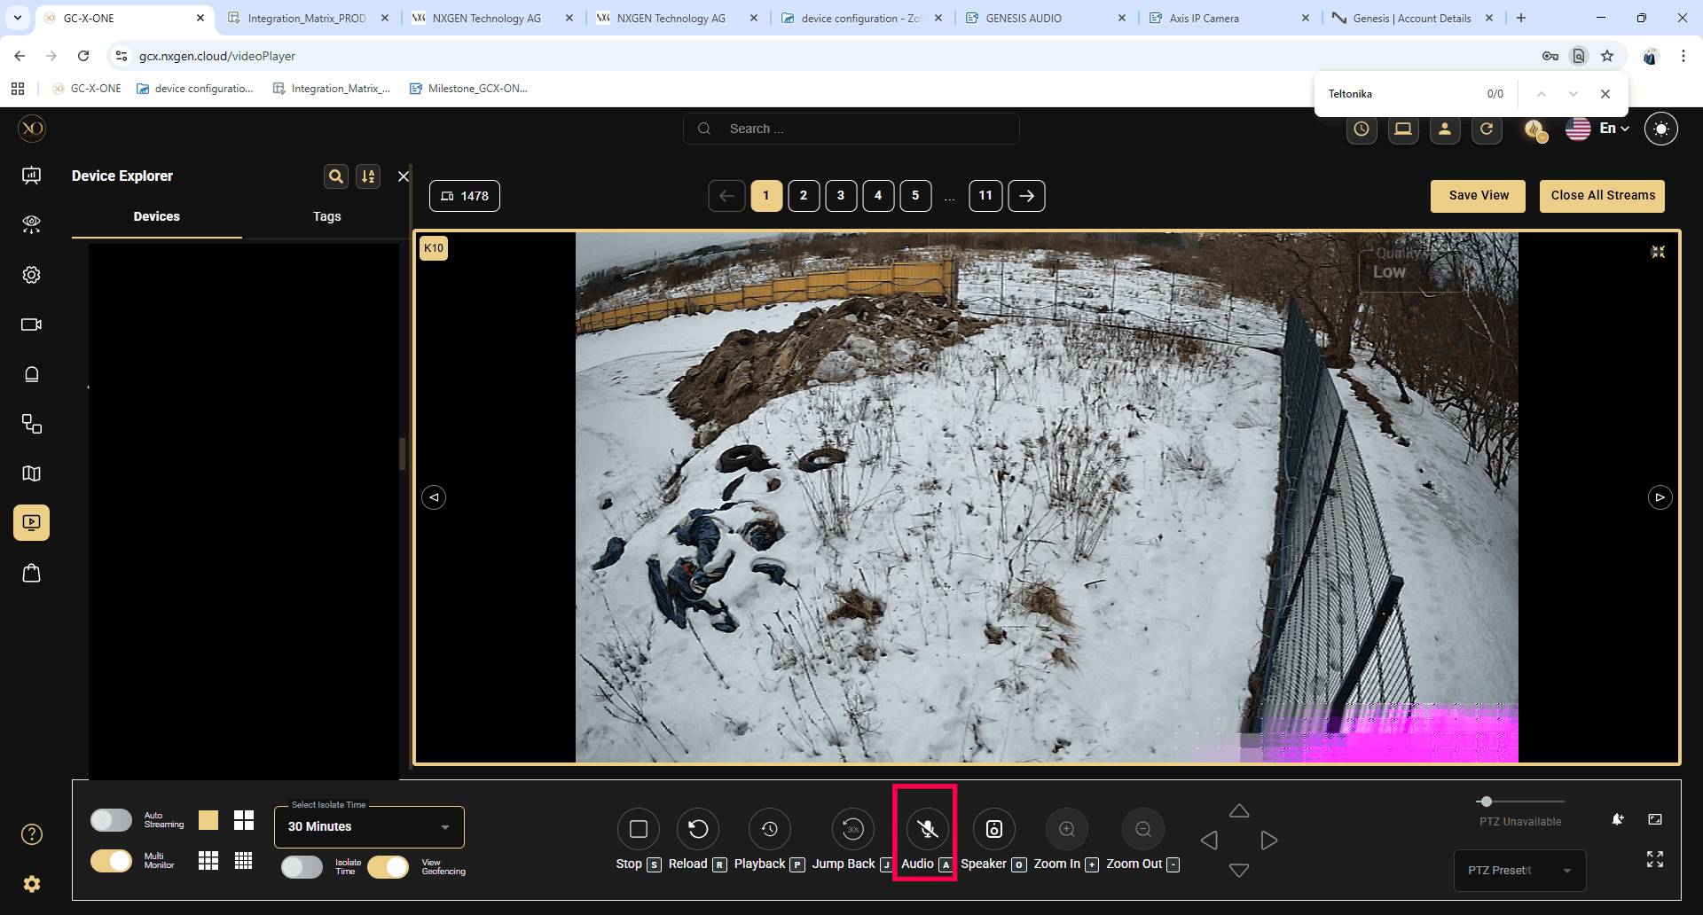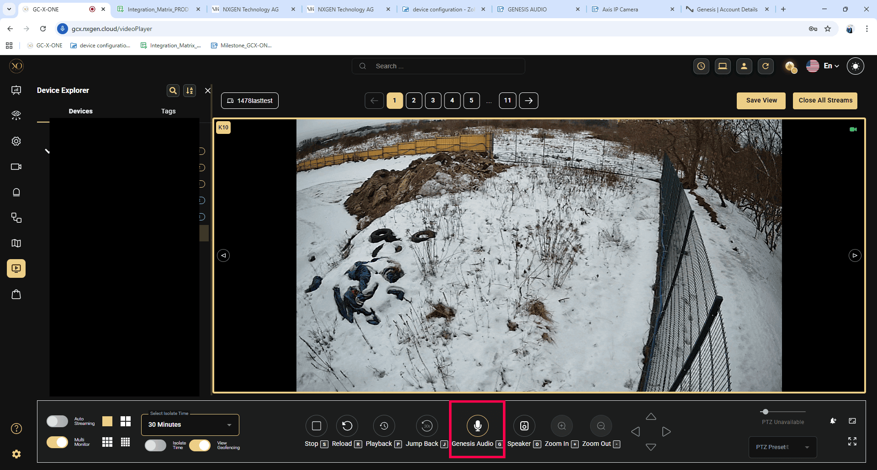
- Open the Network Tab and check the websocket for the following messages:
- Mic On
- Mic Off
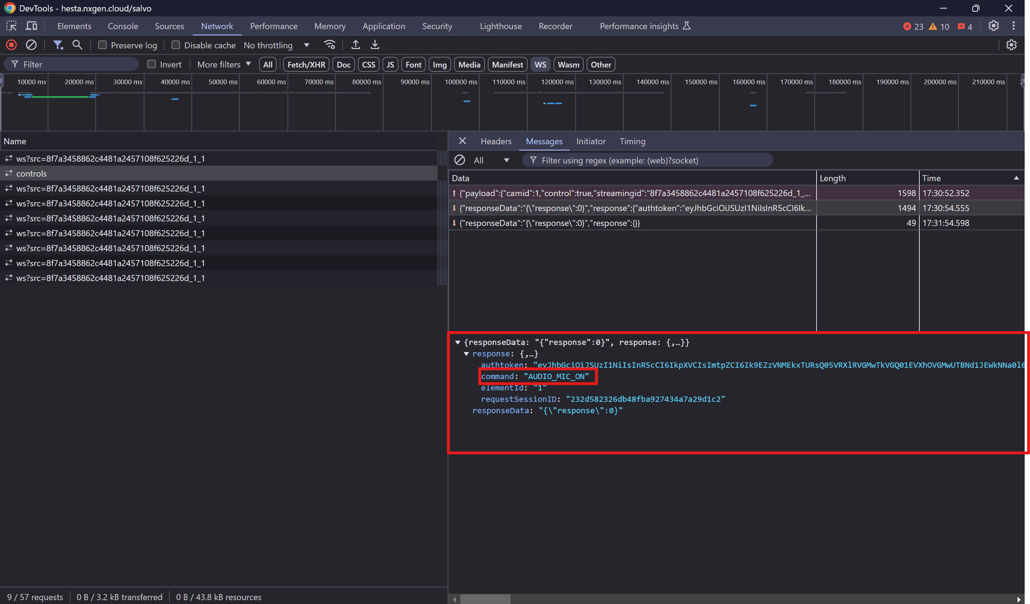
- Verify playback functionality by clicking on various times in the timeline to confirm that playback works as expected.
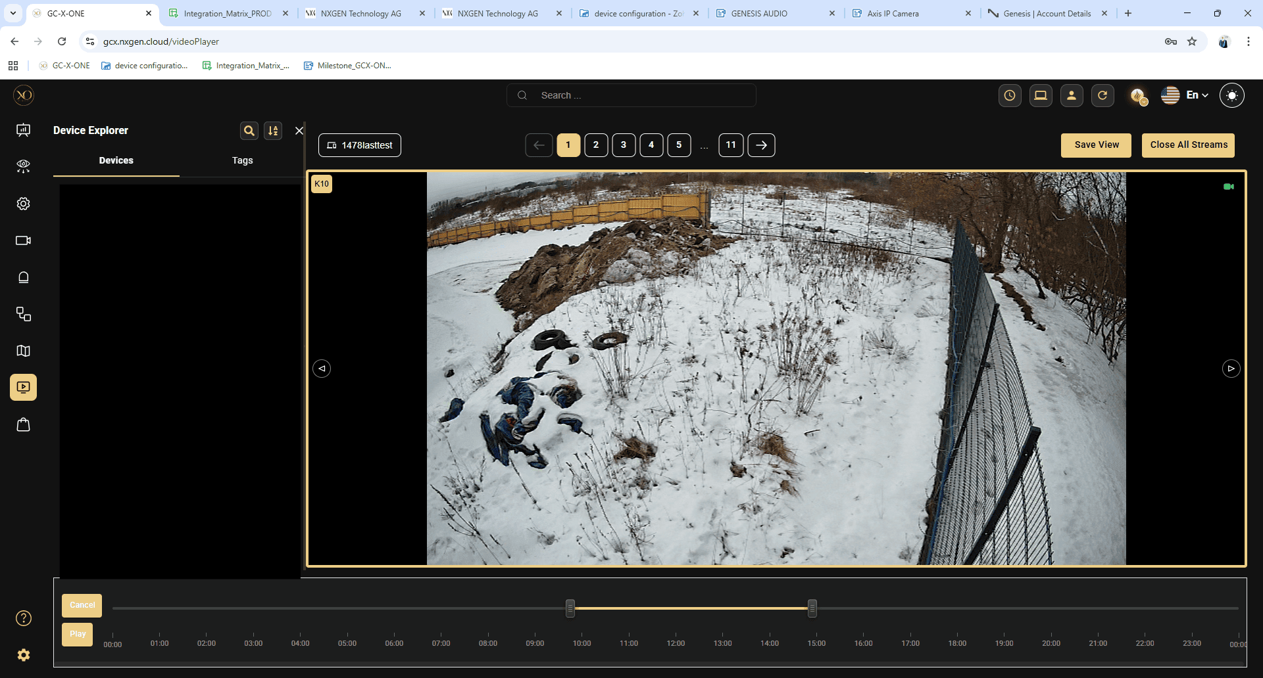

3. Log Verification

Log Path
Logs for the application are located at: C:\nxg\Log\

Steps to Verify
- Open the log.txt file.
- Check for the following entries:
  - Live View Started Call
  - Audio On and Audio Off
  - Playback connection
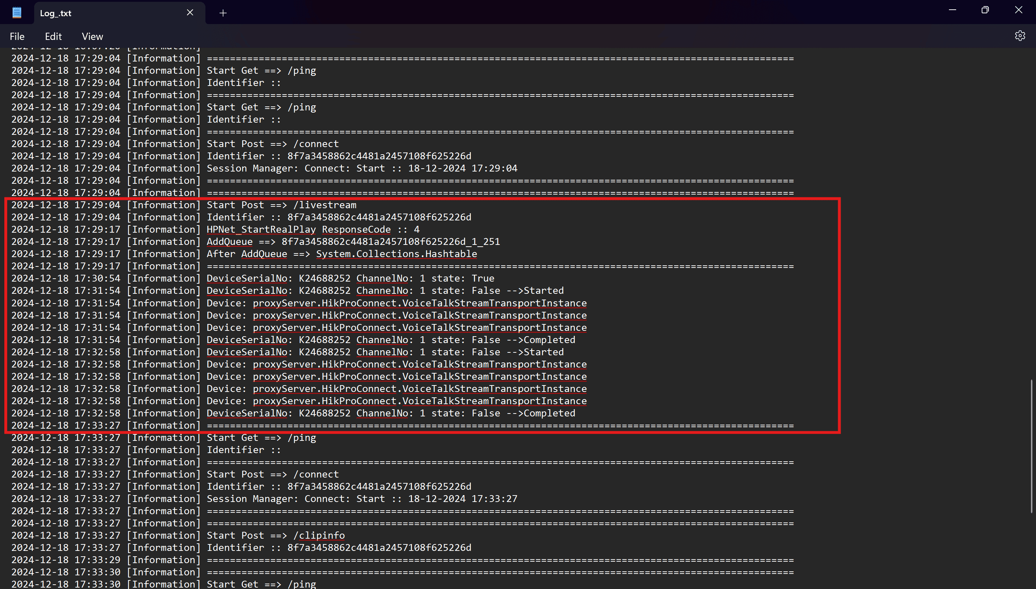
These steps ensure comprehensive verification of the HikProConnect functionality, including live streaming, audio checks, playback, and log analysis. Ensure all steps are completed to validate the application and client.

HikProConnect Device Configuration Guide with GCX-ONE
This document describes the steps required to configure a HikProConnect device in GCX-ONE.

Step 1: Log in to GCX-ONE.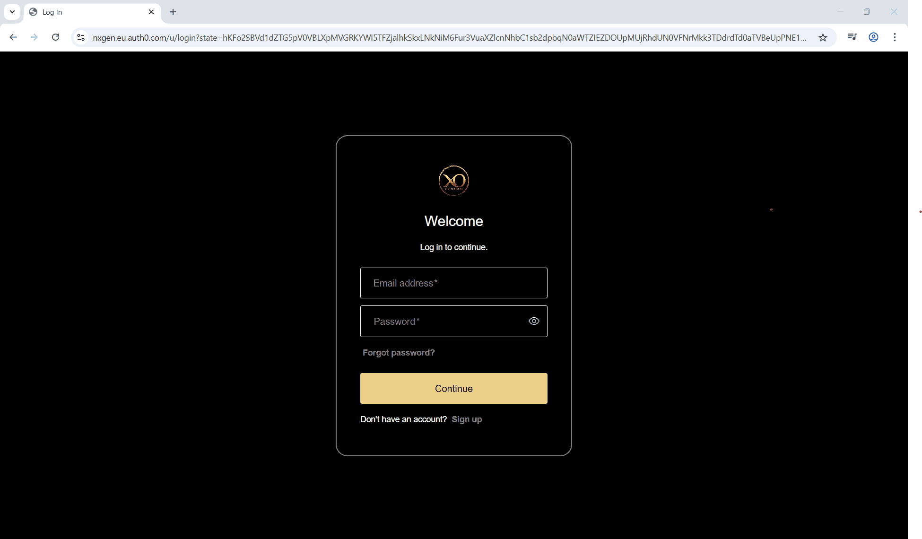
Step 2: Click on the Configuration menu.
Step 3: At the Service Provider level, click on Customers.
Step 4: Click the Add button.
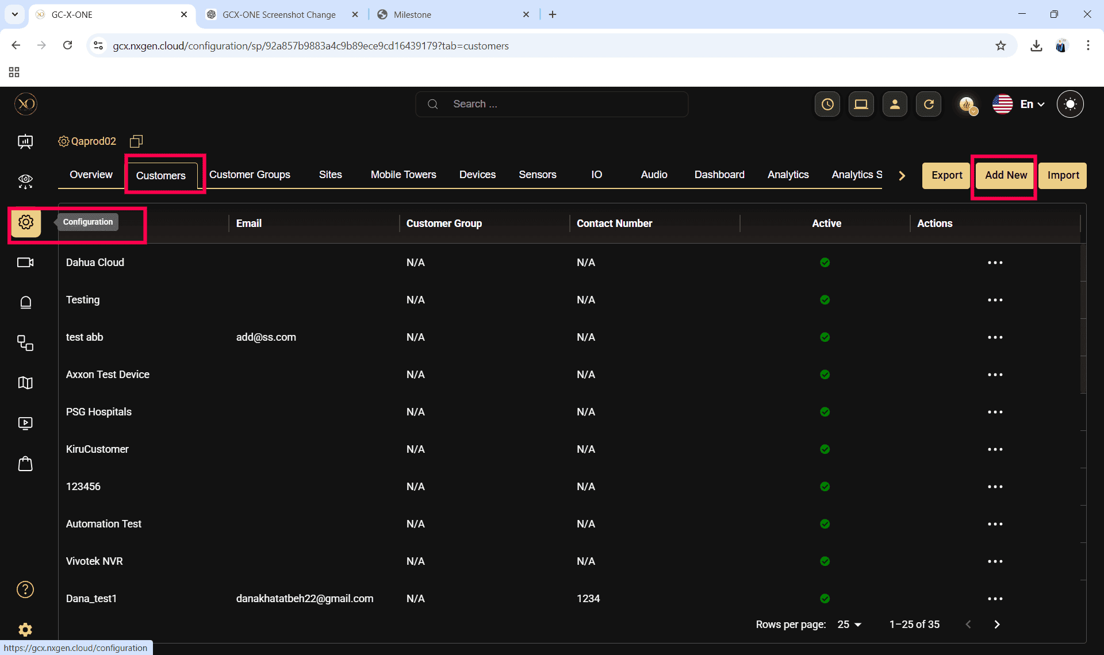

Step 5: Enter the required fields and click Save.
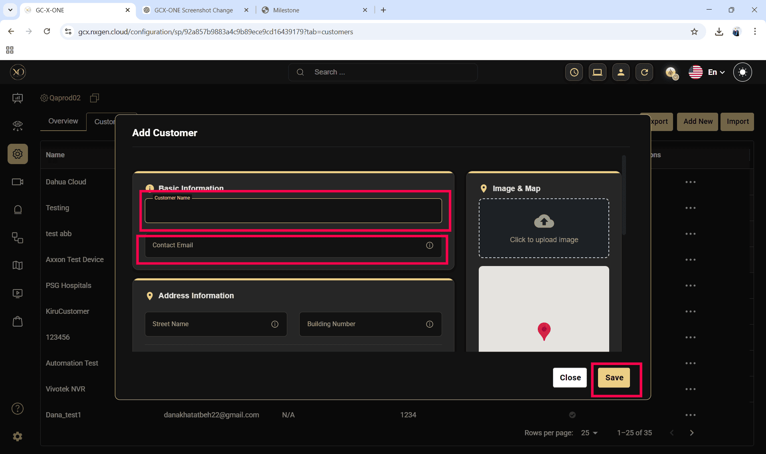
Step 6: Select the newly created customer.
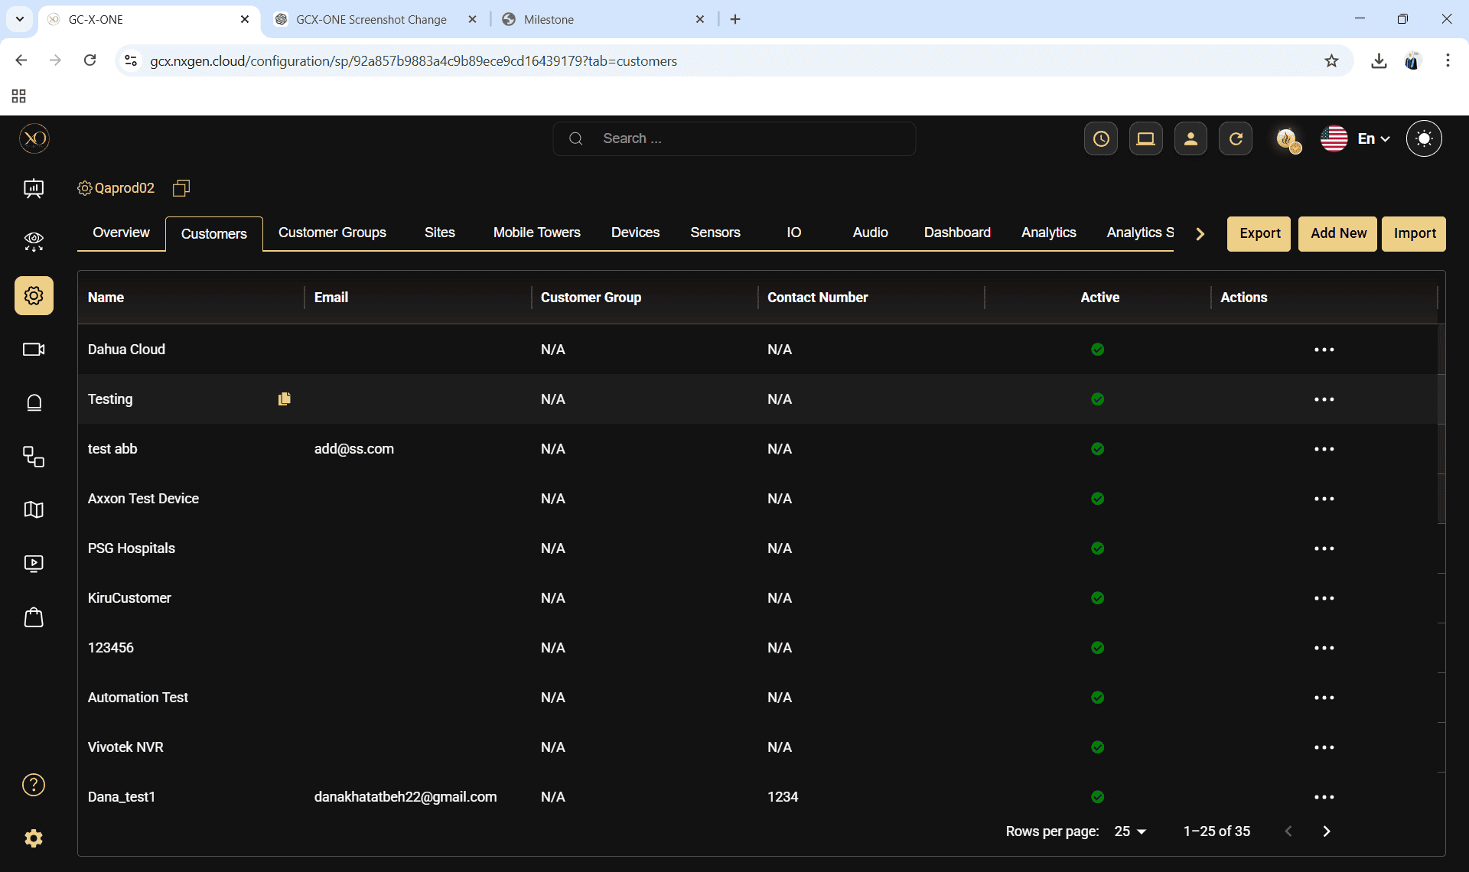

Step 7: Navigate to the Sites tab.
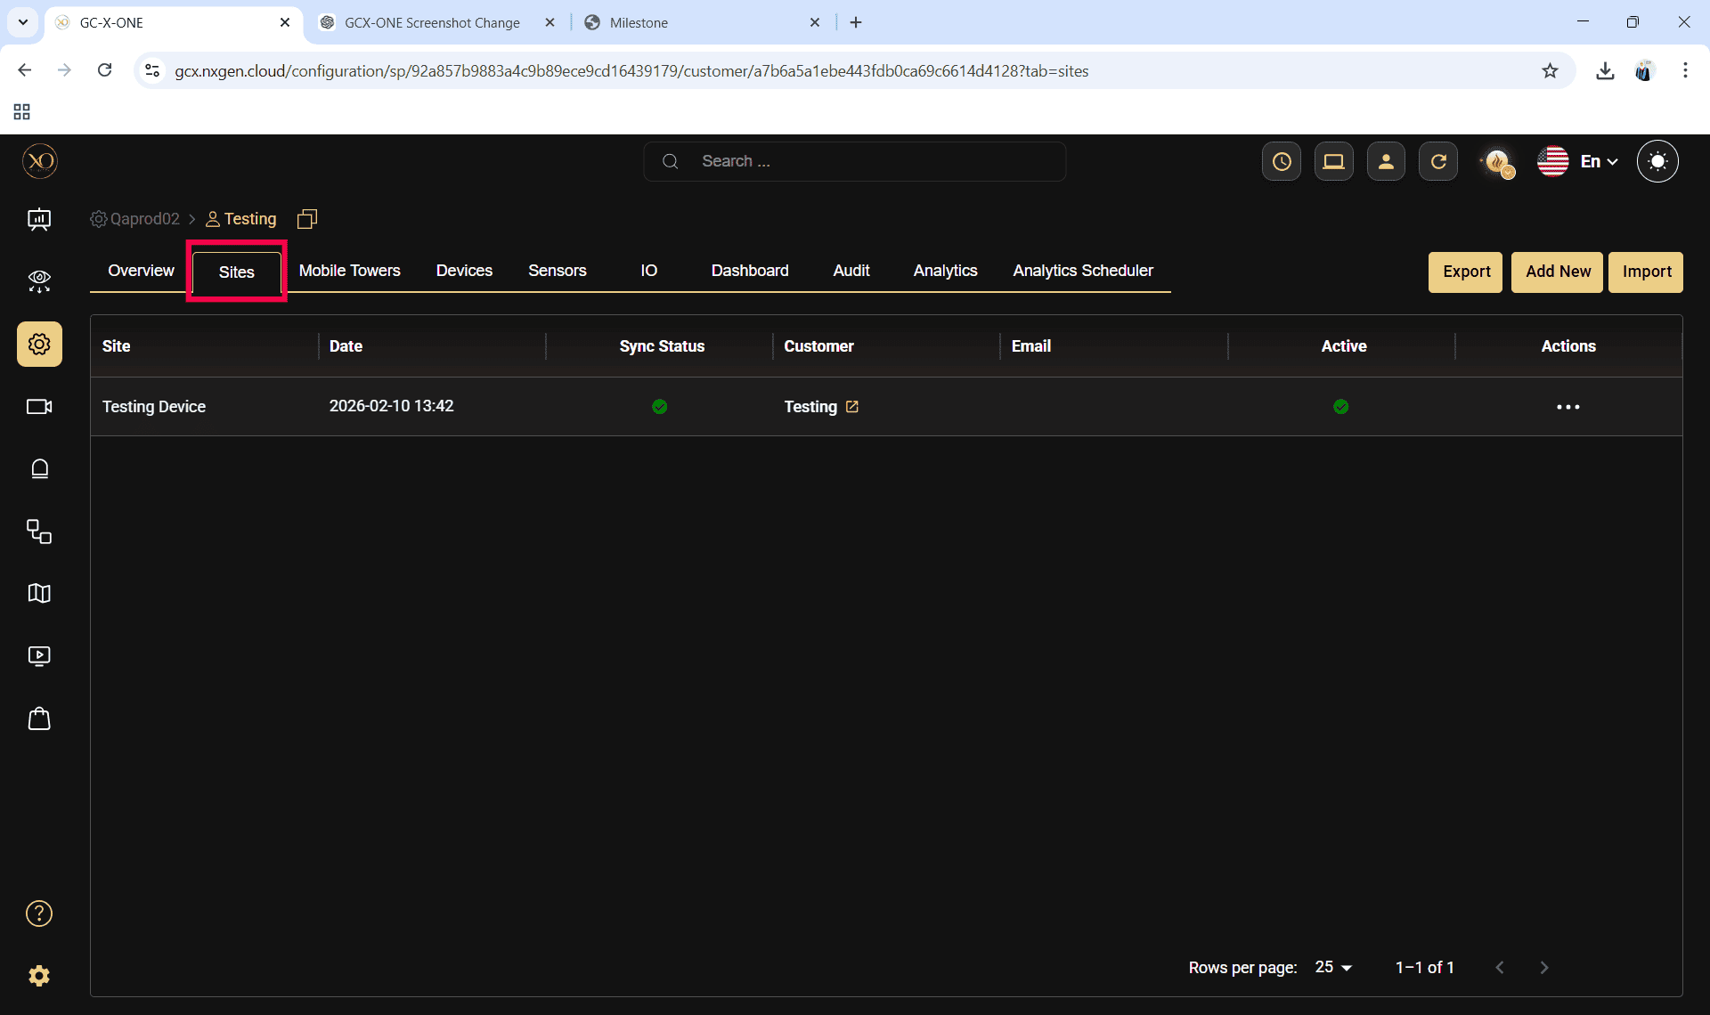
Step 8: Click the Add button.
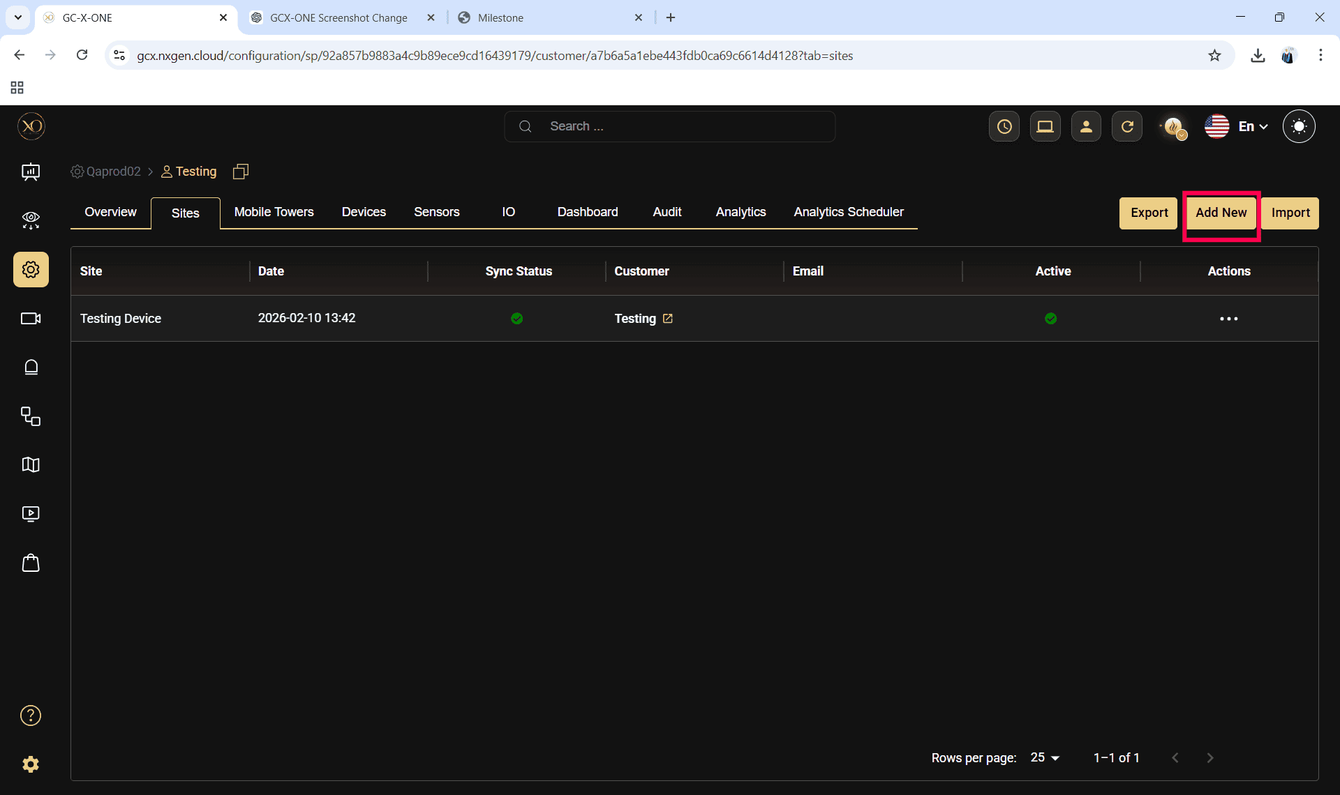

Step 9: Enter the required fields and click Save.
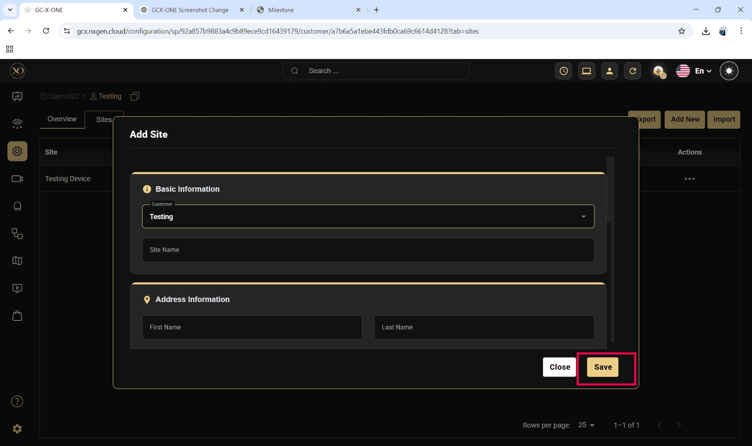

Step 10: Select the newly created site.
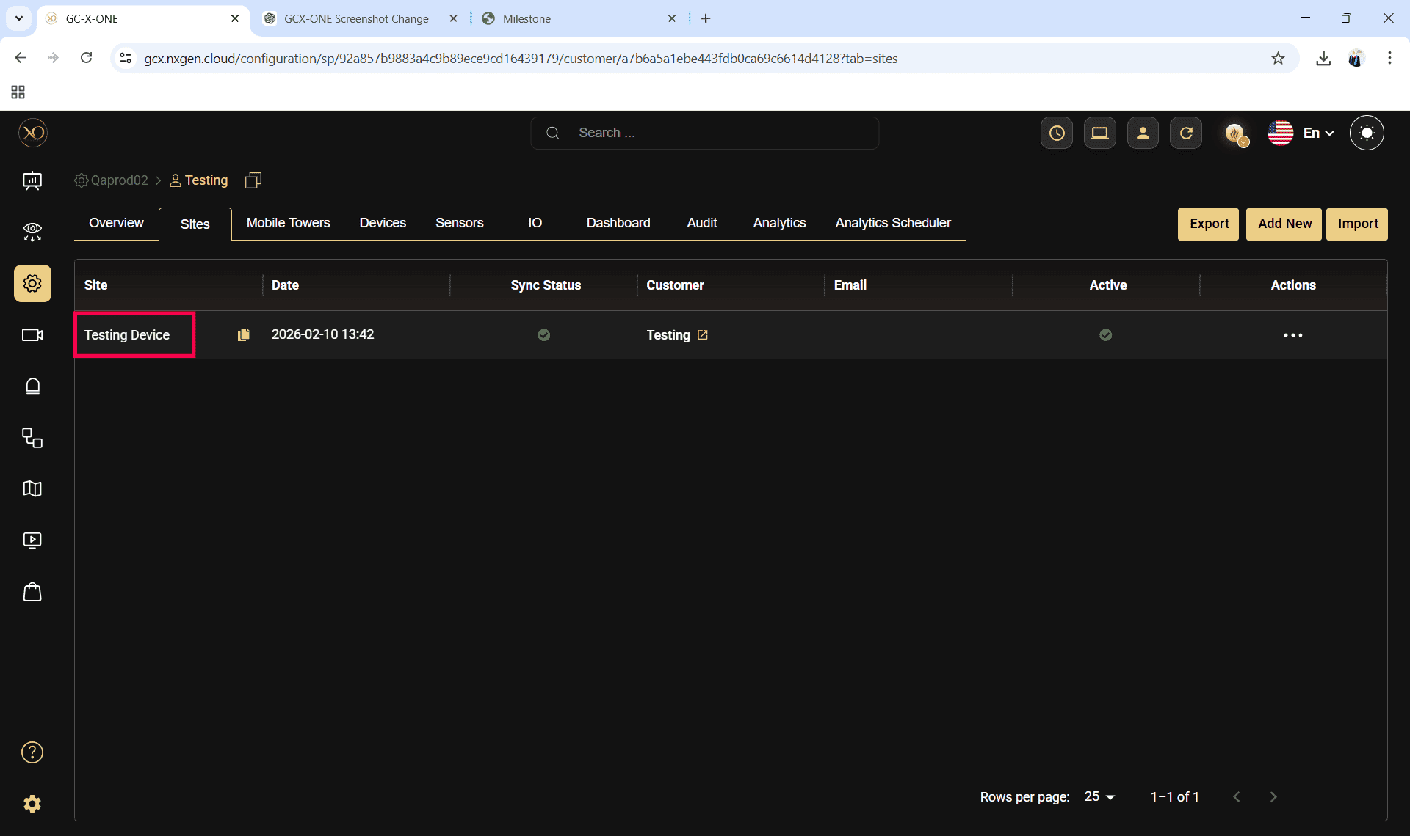

Step 11: Navigate to the Devices tab.
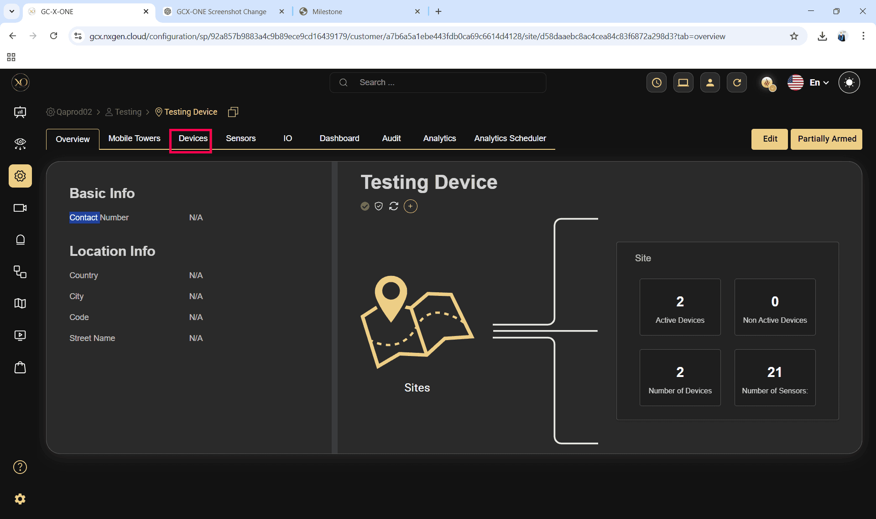
Step 12: Click the Add button.
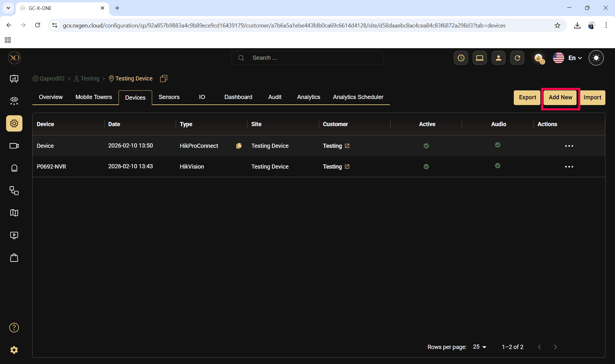

Step 13: The Add Device dialog will be displayed.
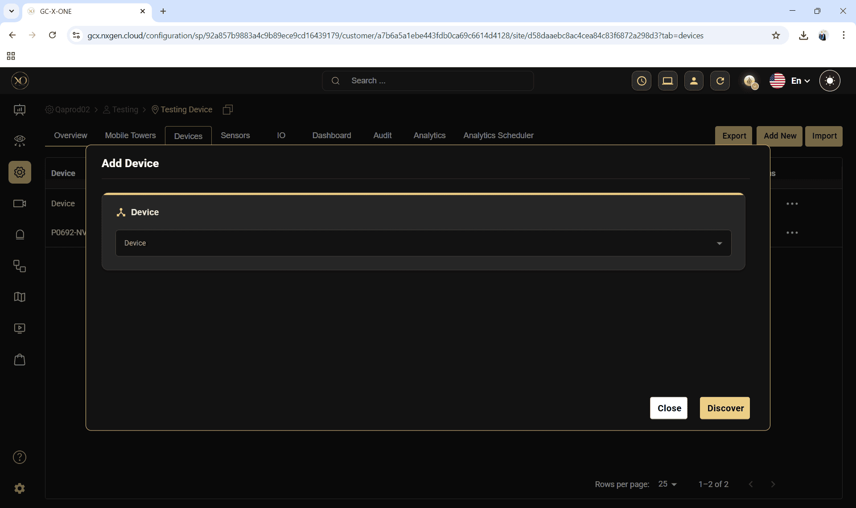

Step 14: In the dialog, open the Device dropdown and select HikProConnect.
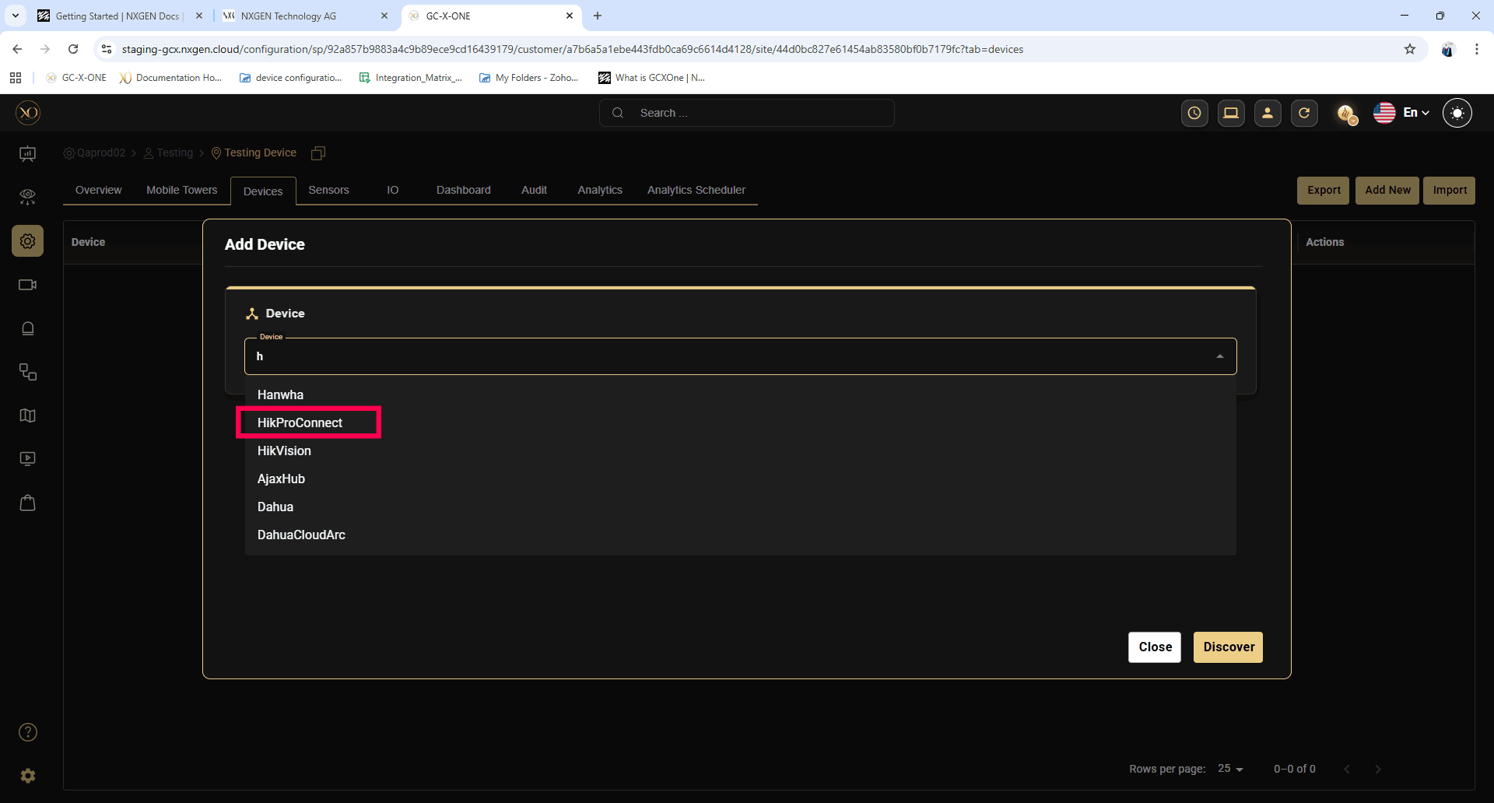

Step 15: Enter all required fields:
- Name
- Serial Number
- Encryption Key
- Timezone

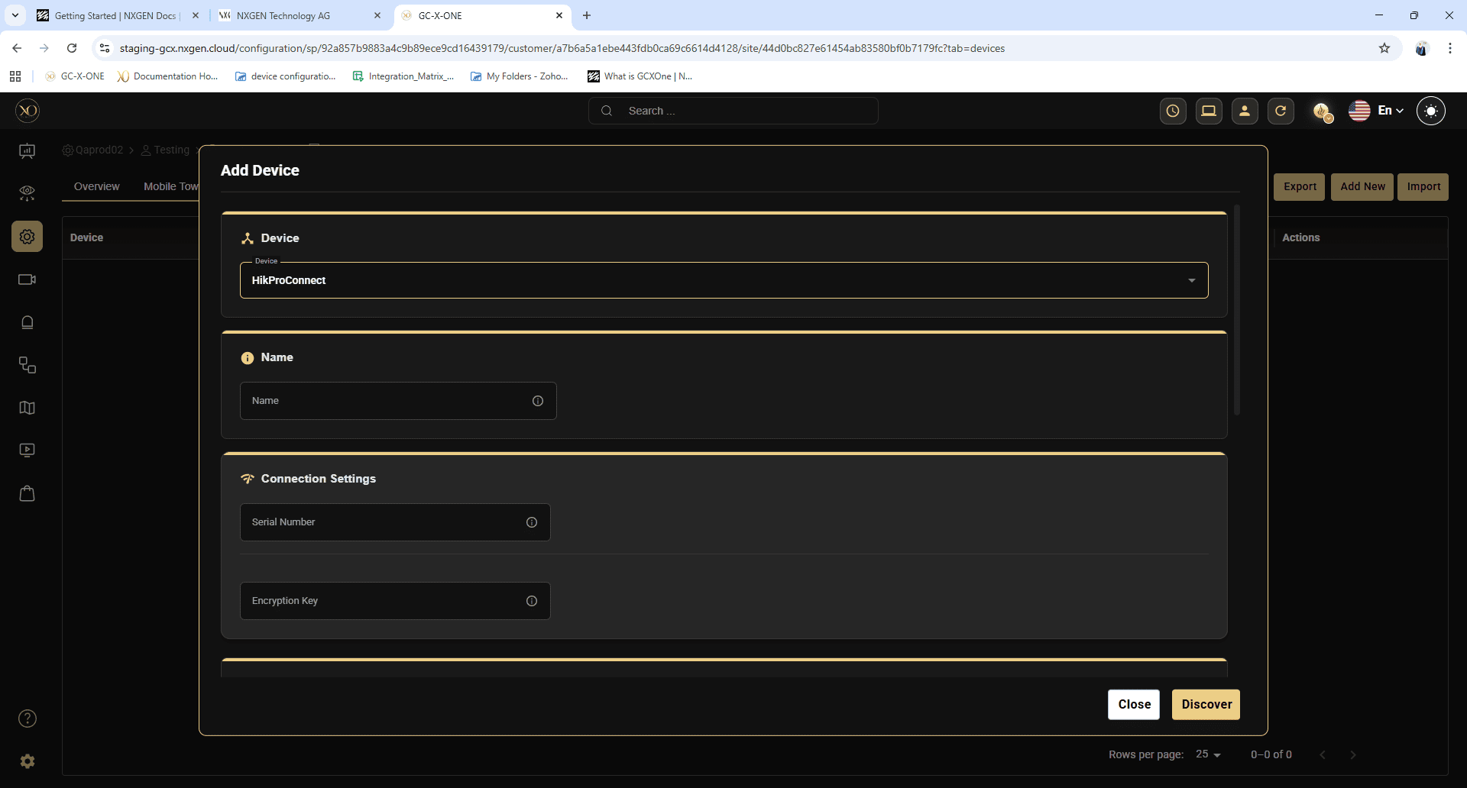

Step 16: Click Discover.
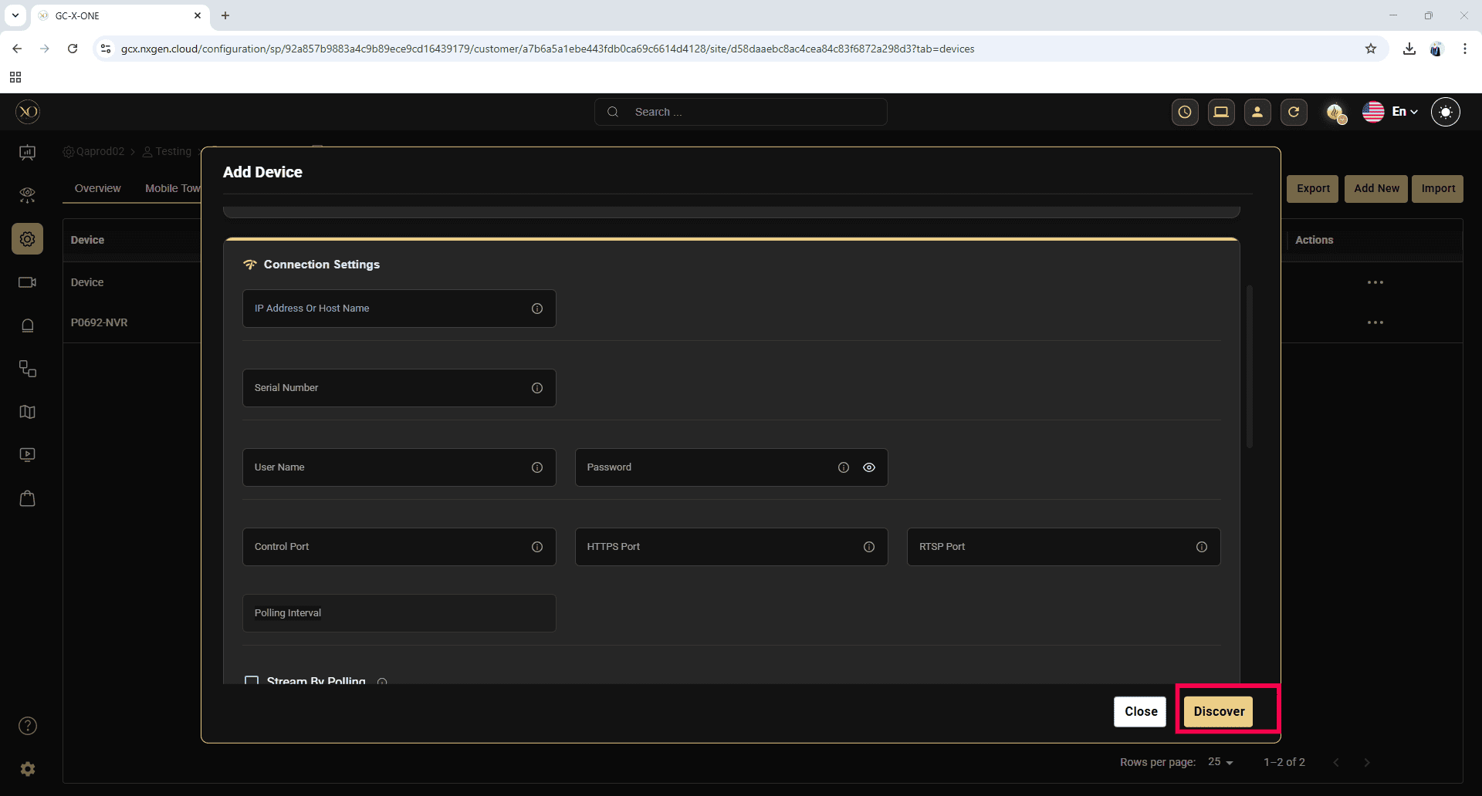

Step 17: Once the device is successfully discovered, click Save.
